1. To Install Linux VM, Configure GCC, Setup Git Repository, Create Project Structure,
Understand Shell Architecture, Build Initial Makefile.
Task-1: Create Project Structure as follows:

OSSP/
│
├── .git/ # Git repository (created automatically)
├── .gitignore # Files/folders Git should ignore
├── README.md # Project description and instructions
├── LICENSE # Project license (optional)
├── Makefile # Build instructions
│
├── src/ # Source code
│ ├── main.c
│ ├── shell.c
│ ├── parser.c
│ ├── executor.c
│ └── builtin.c
│
├── include/ # Header files
│ ├── shell.h
│ ├── parser.h
│ ├── executor.h
│ └── builtin.h

├── obj/ # Object files (.o) (generated)
│
├── bin/ # Executable file (generated)
│ └── my_shell
│
├── docs/ # Documentation
│ ├── design.md
│ └── report.pdf
│
├── tests/ # Test programs
│ ├── test_parser.c
│ └── test_executor.c
│
├── scripts/ # Helper scripts
│ └── run.sh
│
└── assets/ # Images/screenshots
└── architecture.png

Note: For creating this structure use mkdir and touch commands.

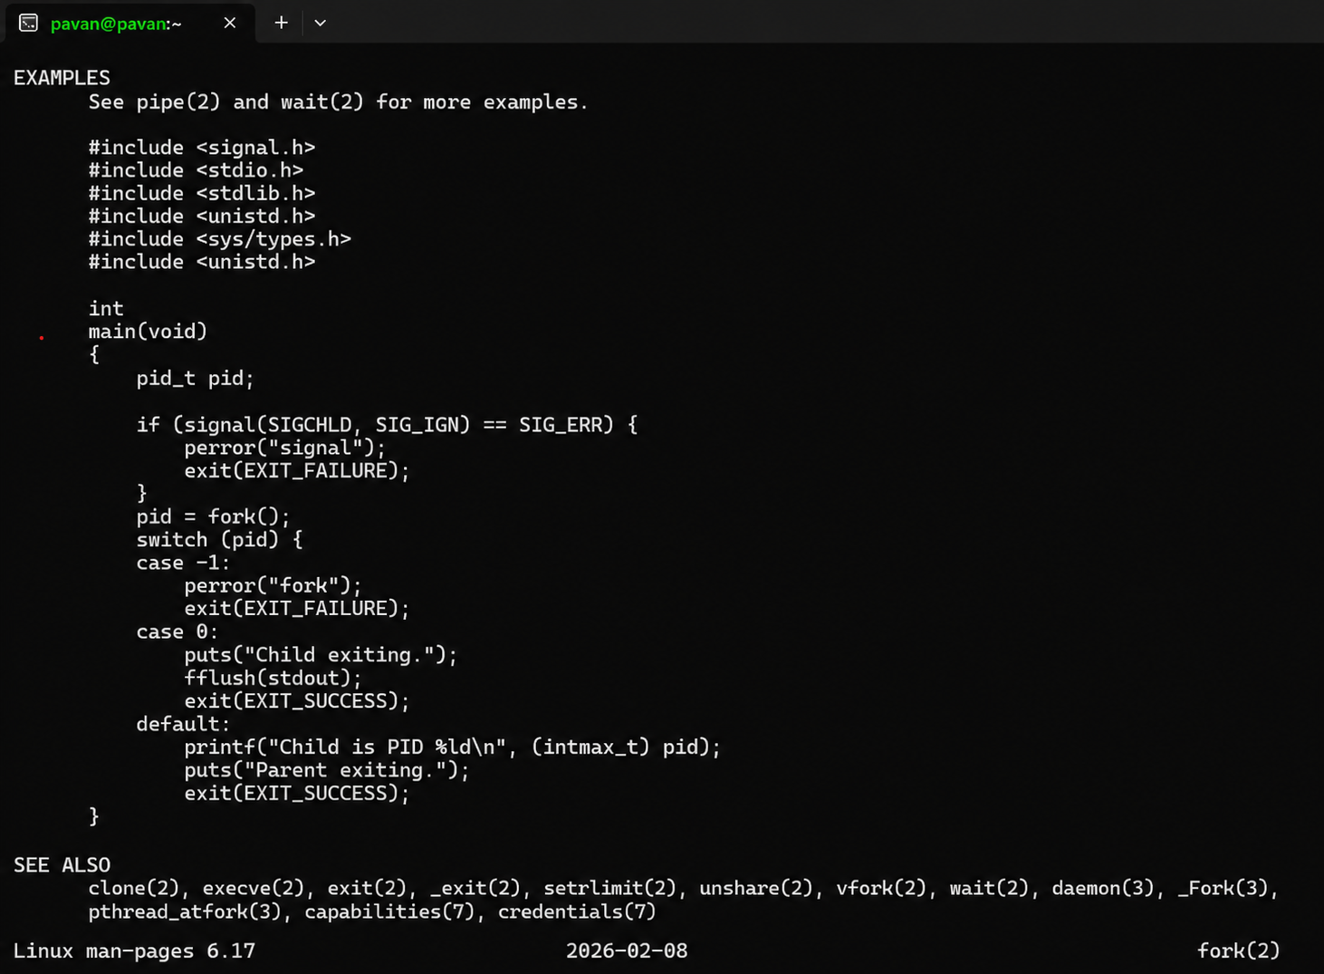

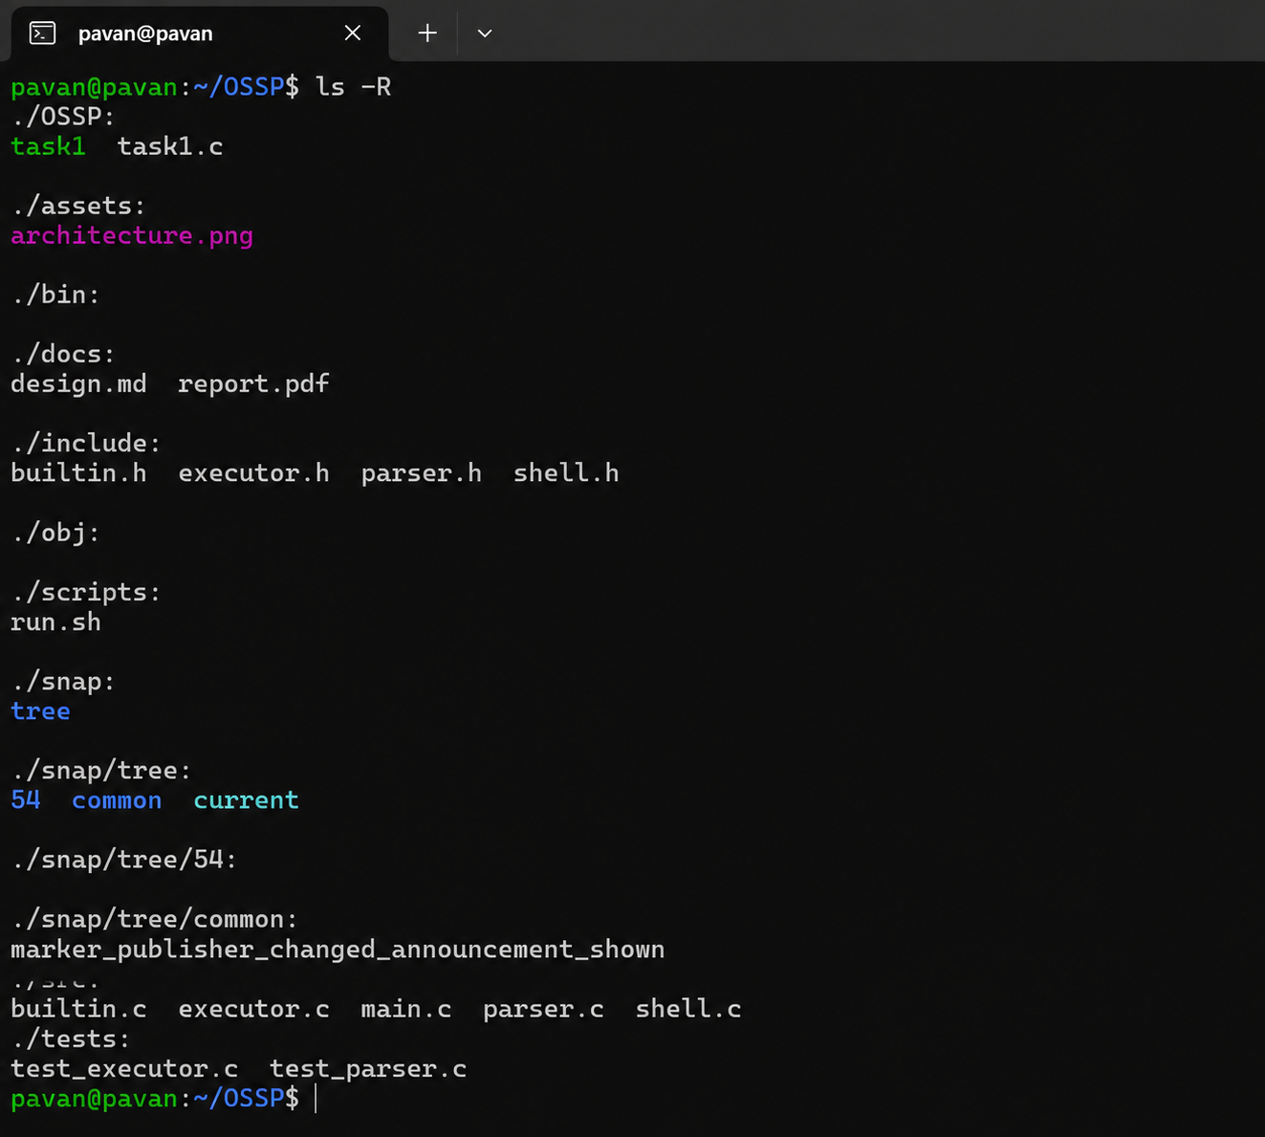

Report:
The source files in src, header files in include, object files in obj, executable files in bin, documentation in docs, tests in tests, scripts in scripts, and images in assets. mkdir OSSP cd OSSP mkdir src include obj bin docs tests scripts assets touch .gitignore README.md LICENSE Makefile touch src/main.c src/shel l.c src/parser.c src/executor.c src/builtin.c touch include/shell.h include/parser.h include/executor.h include/builtin.h touch docs/design.md docs/report.pdf touch tests/test_parser.c tests/test_executor.c touch scripts/run.sh touch assets/architecture.png git init ls -R.The OSSP project structure was successfully created and a Git repository was initialized. The Linux environment was successfully prepared for developing the Operating System Shell Project using GCC, Git, and Make

2. To Analyze process abstraction, execute fork(), understand exec() family, analyze parentchild relationships, inspect process tree, practice system call tracing.
Task-1: Using a manual command understand the fork() and exec() system calls

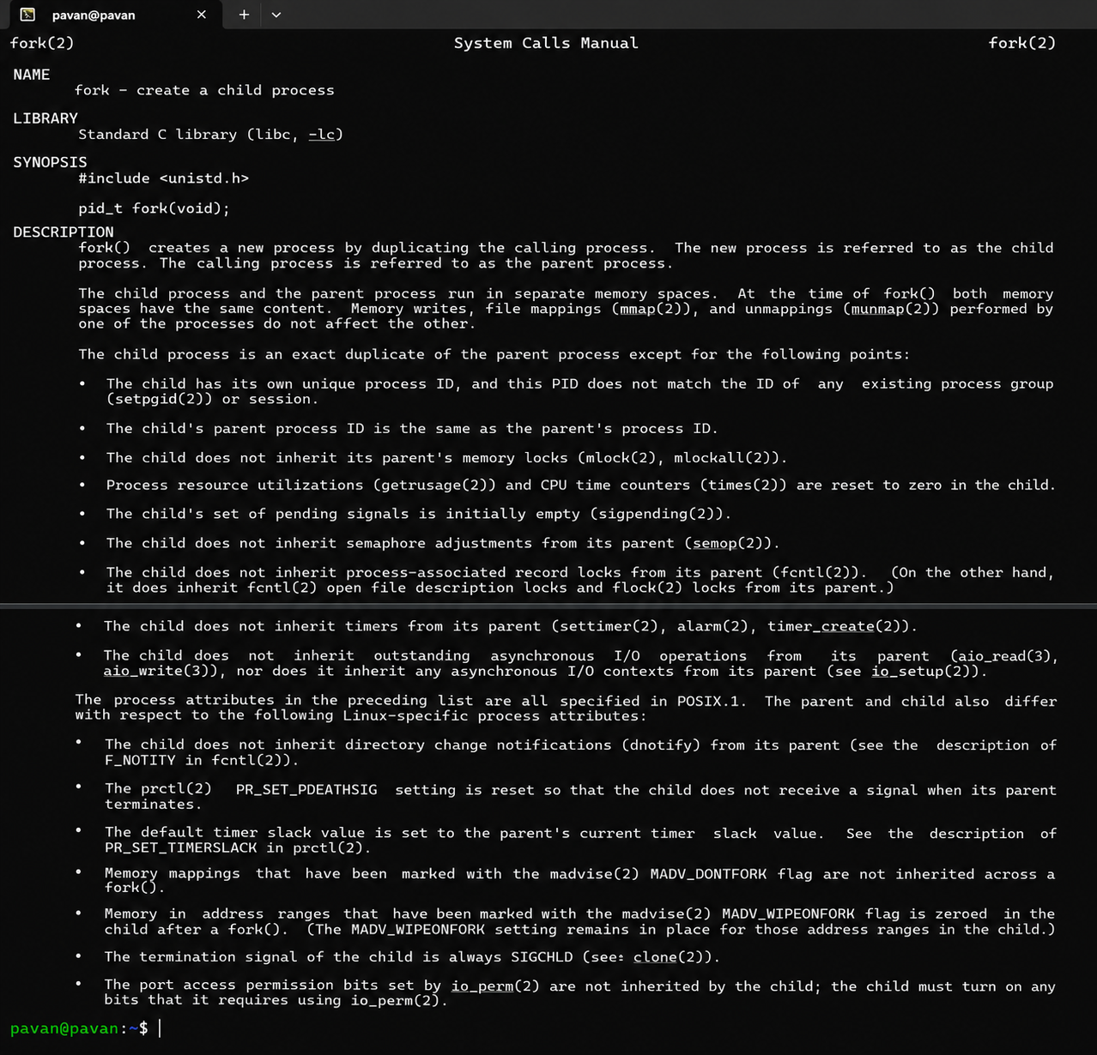

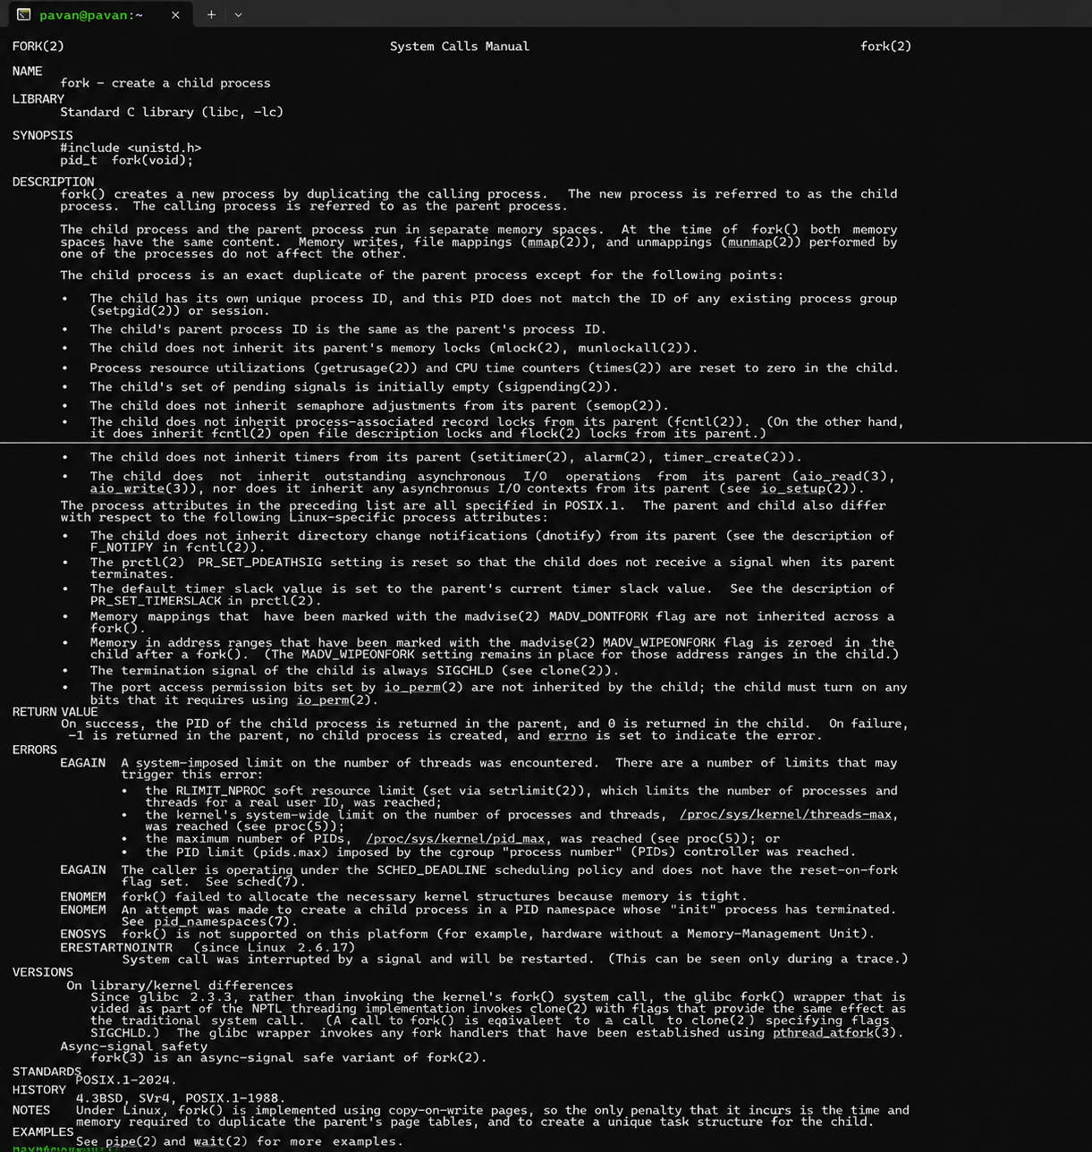

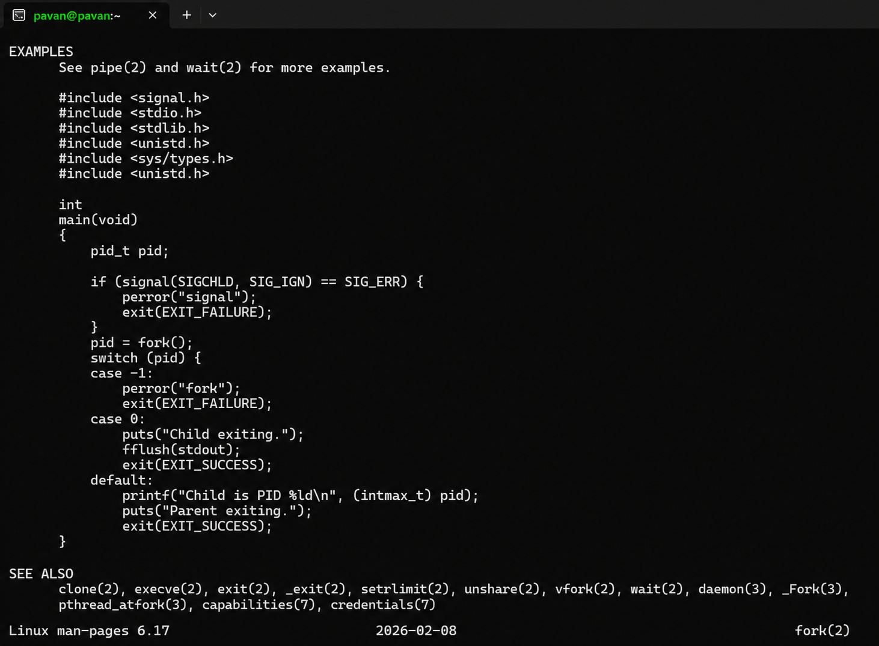

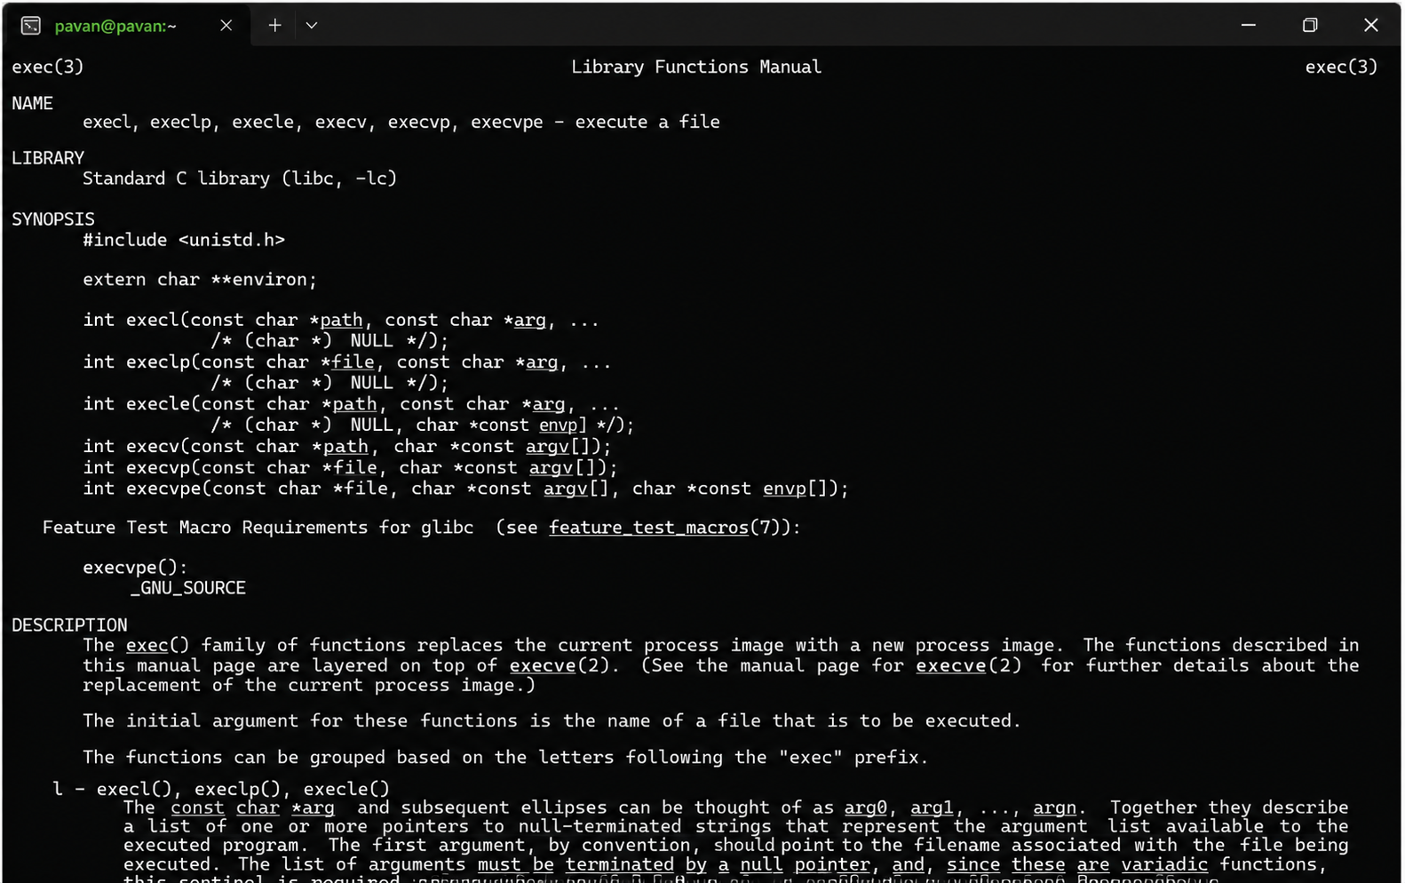

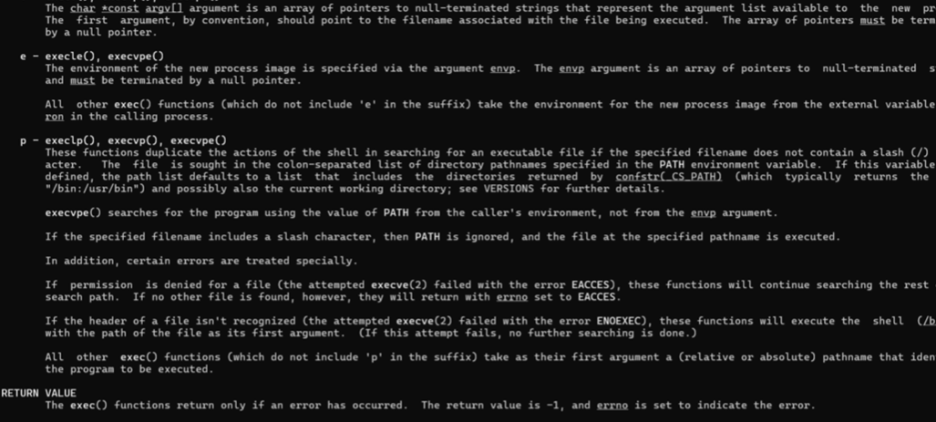
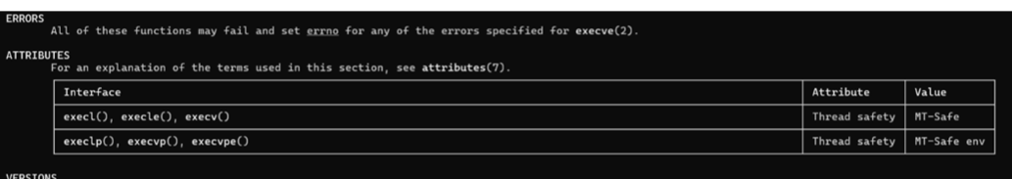
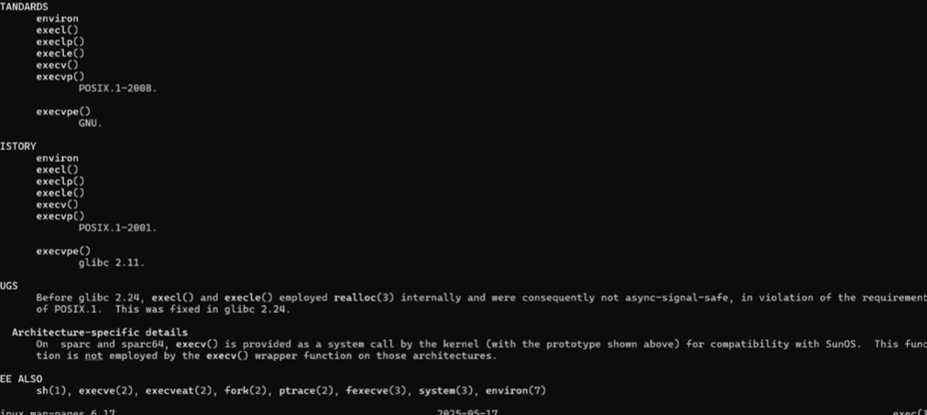

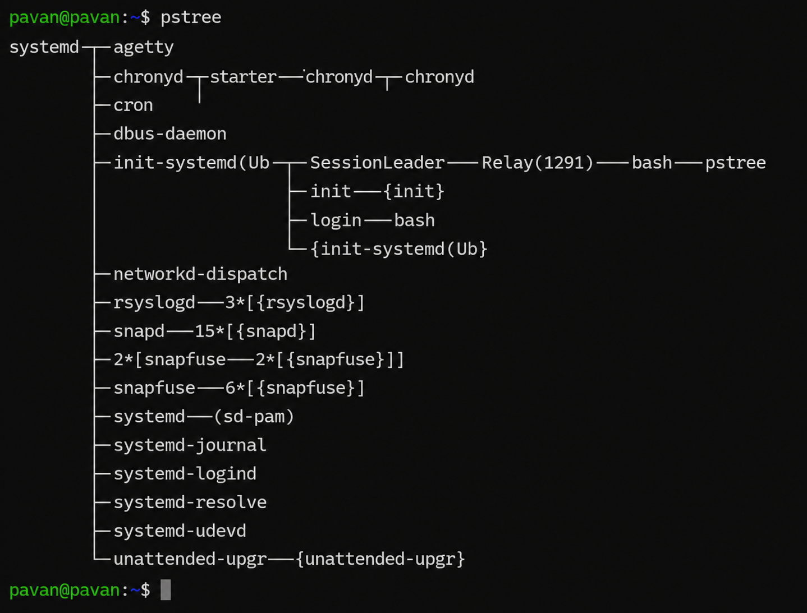
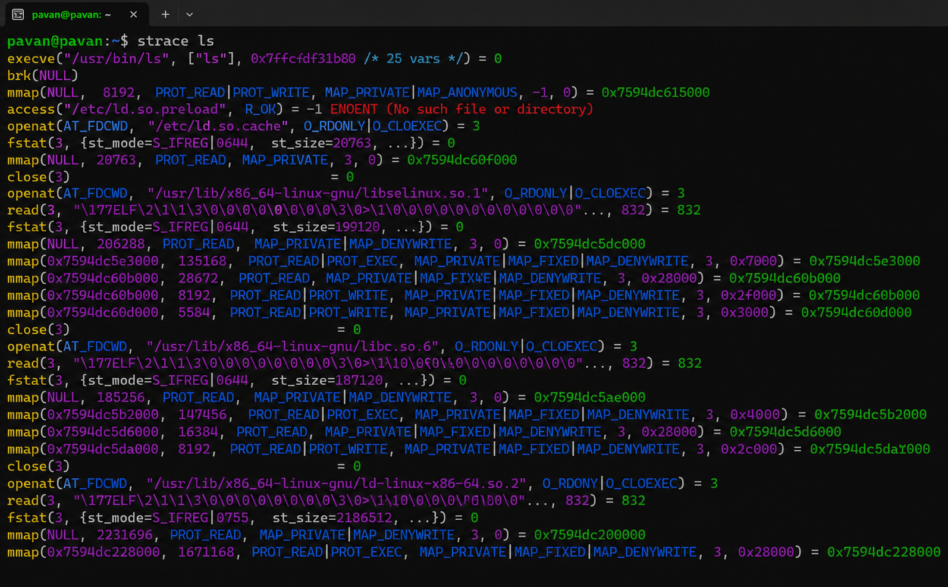

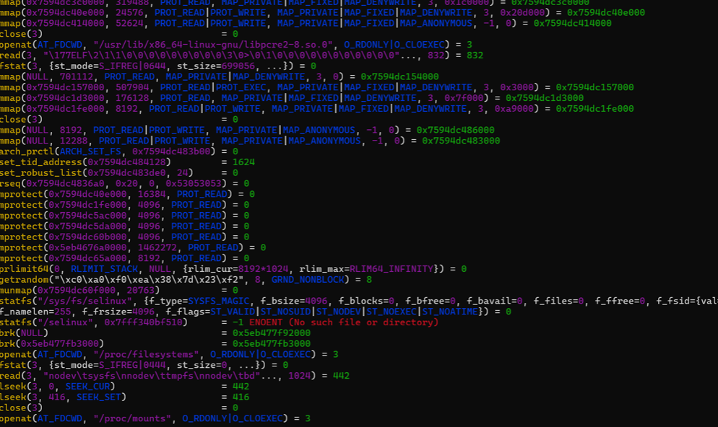
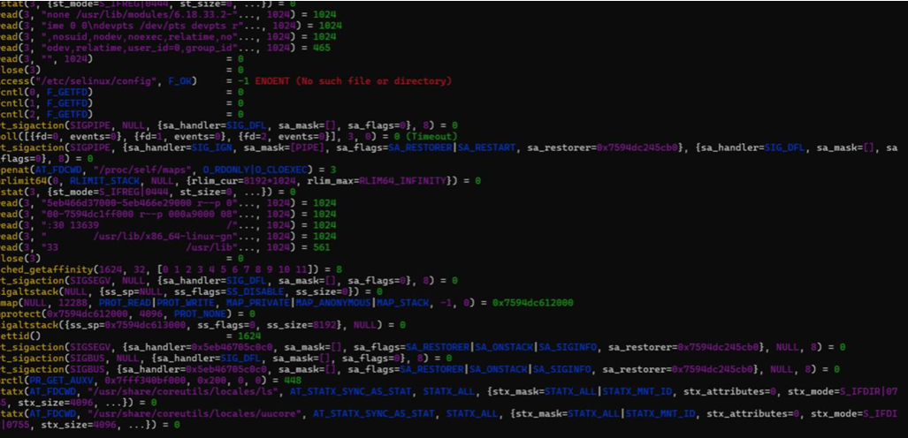

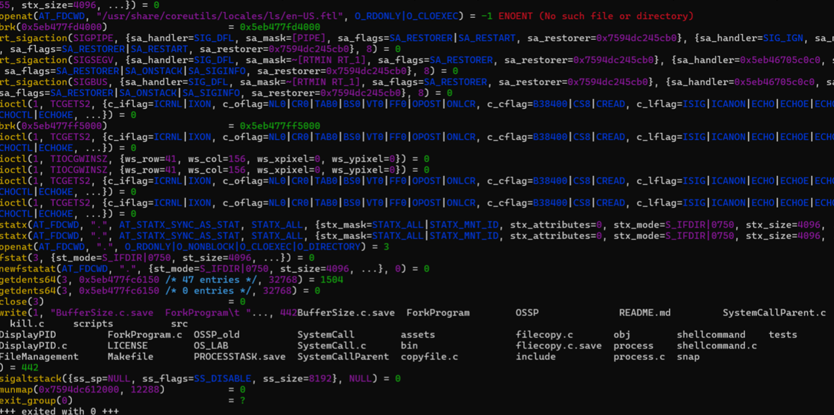
Task-2: Write a C program to create a new process and accepting the user commands using fork() and exec() system calls.
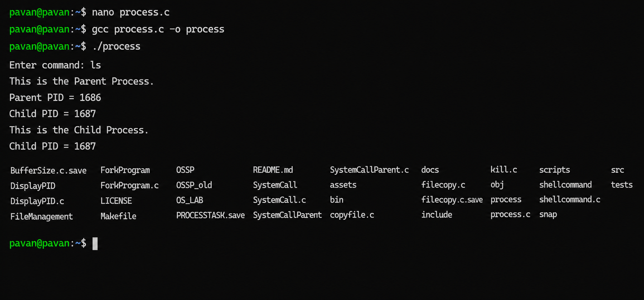

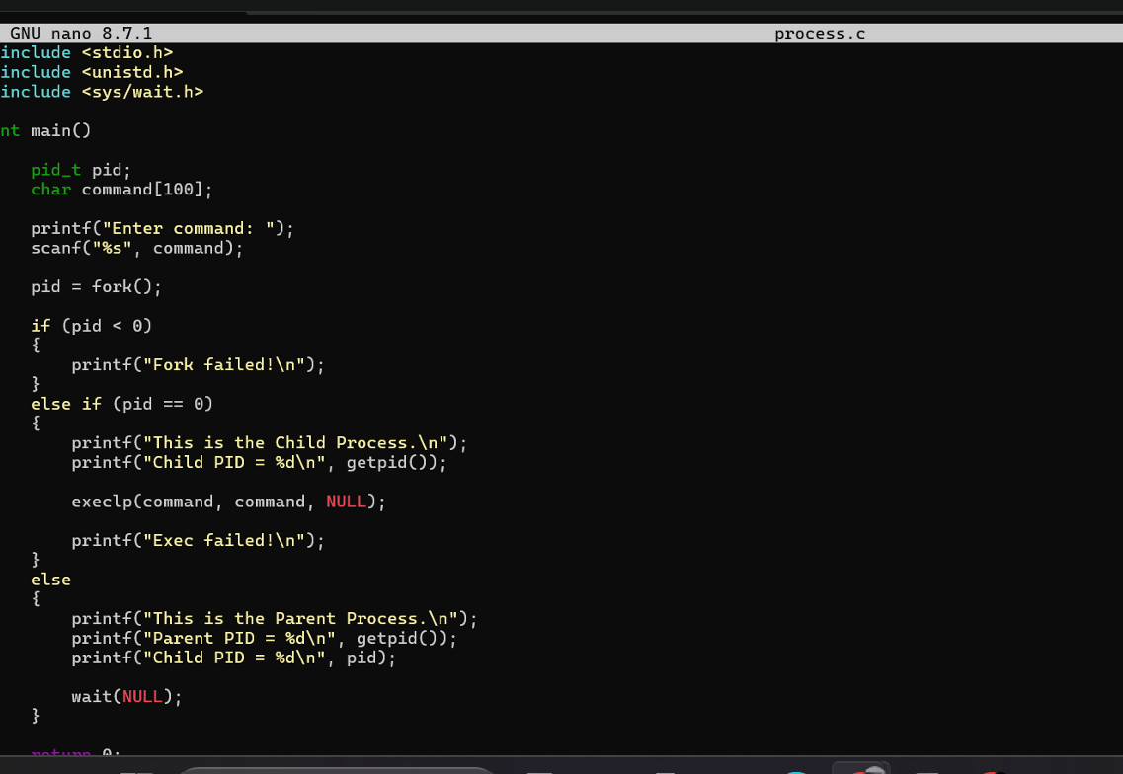
Report: A child process was created successfully using fork(), and the user command was executed using exec()man 2 fork man 3 exec pstree strace ls The experiment successfully demonstrated Linux process creation and execution using system calls

